SOME UDDIN
SOME OF OUR FLOURISHED START-UPS INCUBATED AT TCGTBI

TO GO THE MARKET

SRIJAN CREATION
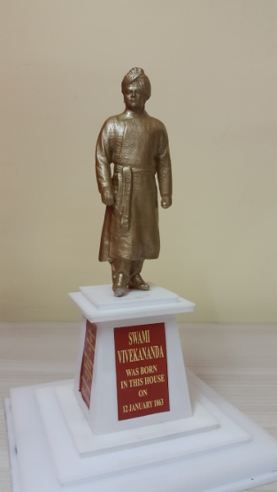
Srijan Creation was formed in the year-2013 by two young enthusiastic in the field of additive manufacturing with a mission to carry out fundamental development on 3D printing technologies, and to provide services for quality 3D printing as per individuals requirement.
Their specializations are:
- Miniature selfies in metal by 3D scanning
- Lithophane Lamp shed from Photo
- Customized Signature of individual And many more
Srijan Creations have won quite a few accolades from various organizations, including a prestigious award from Government of West Bengal.

fontikulus
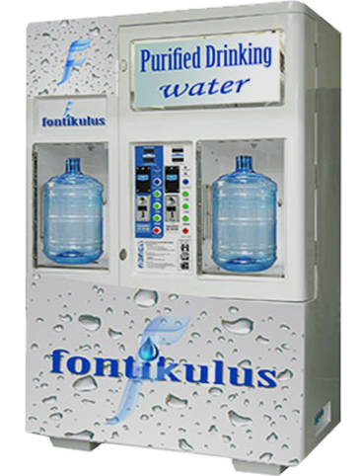
fontikulus is a professional water management company, working in the consultancy field of Water, Waste Water treatment and recycle. They are manufacturer of Solar Operated Water Vending machine which is an excellent solution for potable water with renewable energy source. Increasing demand for clear water and increasing awareness about benefits of consuming purified water are key factors of growth for our vending machine business.
Our working area covers- Water Treatment Plant, Effluent Treatment Plant, Sewage Treatment Plant, RO Systems, Package Drinking Water Treatment Plant, Rain water Harvesting, Water and Wastewater Management feasibility studies including recycling and reuse facility for Zero Liquid Discharge option, Augmentation/Up-gradation Work of existing Plants.

CAPACLOUD TRADING SOLUTIONS
CAPACLOUD, India's the most avant​-garde climate change company is pioneering a new generation vertical garden product that is maintenance free, connected through IOT and smart enough to let a variety of plants grow on any vertical surface or structure. It has won several awards such as India's Top 30 Technology Company, Economic Times Power of Ideas, Most Promising Start-up in West Bengal and University of Chicago Urban Labs Challenge.
COSTEEL PROCESSING (P) LTD.
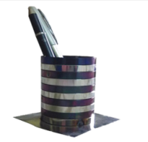
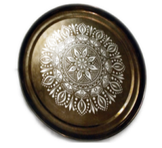
COSTEEL has been formed by a group of IIT-Kharagpur alumni in order to commercialize various products of coloured stainless steel. Unique part of the innovation is that different colours are achieved by controlled oxidation of AISI-304, AISI-316 grades of stainless steel because of “Selective Absorption” of light at different nanometric levels of the artificial oxide films. Another unique aspect of their creation is that Science and Technology gets combined with Art by using a masking agent. Existing products are Souvenirs, Mementos for corporate bodies & academic institutions, self portraits, portraits of famous people and art forms such as Pata-Chita of Bengal. Stainless steel enables the art forms and other products as permanent without any deterioration.
Nayan Eye Centre
Adequate dilatation of the pupil with medicated drops is necessary for safe Cataract surgery and implantation of an Intraocular lens (IOL). The pupil does not dilate adequately with medicated drops in 7 to 10 percent of eyes and needs to be mechanically expanded using a ‘Pupil expander’. Nayan Eye Centre has invented B-HEX Pupil Expander (Bhattacharjee Pupil Expansion Ring) that is easier to use and provides adequate and safer expansion of the pupil compared to competition.
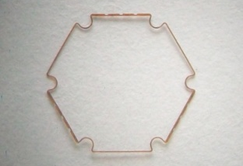
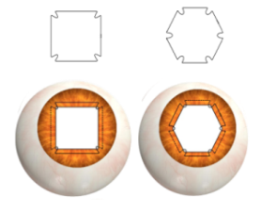
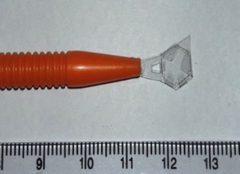

The B–HEX Pupil expander would be
- Easier to use Pupil Expander device for Eye Surgeons,
- Safer pupil expansion for patients,
- Economical Solution for health care systems and Governments worldwide
SOME OF OUR BUDDING STARTUPS AT TCGTBI
Leopard Trans LLP
They have developed an App for providing transportation logistics by linking both the consigner and consignee through a common application that can be used on computers and smart phones.
Flip Motor Corp Pvt. Ltd.
Converting a bicycle into a motorized bike using low capacity engines and subsequently adding on certain accessories retro-fitting with 49cc, 4 stroke petrol engine and vacuum air cooling system having very high fuel efficiency with a power of 2hp/ 6800 rpm.
Maybright Ventures Pvt. Ltd.
Developed an APP, named mPokket providing peer-to-peer lending platform that acts as a marketplace for borrowers and lenders. They facilitate loan transactions but do not lend from their balance sheet or bear any responsibility for repayment.
PedaZoom
PedaZoom is being promoted by some of the alumni of IIESTS with the objective of reaching out to the students of colleges/universities and also to the professionals employed in the industries with short-term industry-oriented courses through online mode. Professors of institutes and engineers from the industries with relevant experience will be the joint instructors in the courses.
Mariposa Green Scape (P) Ltd.
Mariposa has come up with an innovative solution to make bio-inputs/fertilizers and pesticides, exclusively using local materials, for preparation and delivery. The problem of soil degradation is addressed by using micro-organisms available in the soil.
Mariposa is bringing indigenously developed superior and adaptable technology at the doorstep of the farmers. One solution does not fit all. Thus customization has been adopted by them, as a marketing strategy. They are treating every land separately, and providing the required and balanced solution. The product, along with unique services will solve the problem of:
- Gradual deterioration in the quality of land by using chemical fertilizers, insecticides, pesticides, etc. on a continuous basis.
- Non-availability and high cost of chemical inputs.
- Causing damage to the surrounding areas including ponds and lakes.
- Excessive use result in detestable produces, often fetching lower prices. This problem is assuming serious proportions in our plantations, that heavily depends on the flavour and aroma, to realise higher prices.
Green Urja & Organic Krishi Development Holding
An energy efficient solar pumping system for irrigation in low solar irradiation zone especially North East region of India and other States having similar topography.
Skai Line Engineering and Construction
It is online paying guest management software which helps paying guests to manage their stay in a systematic and more convenient way and allows PG owners to be a part of the same family.
Racekin Web Pvt. Ltd.
It is basically a social media website but the concept is different from others, as it would provide a platform to discuss the recent social issues; of local, national or global relevance to bring certain possible solution, without revealing one’s identity.
MOTORCADE
Motorcade is a Peer-to-Peer social platform for MOTOTOURERs (people who take their own cars/motorcycles for long distance trips for purpose of leisure) with an in-house e-commerce segment, both of which will cater to the needs of mototouring. The company will provide a bridge between vendors and customers of mototouring products such as car/bike accessories, spare parts, aftermarket modifications, riding gear (protective) and luggage.
Birdwing
Birdwing, a startup business proposes to publish printed books and e-books (including kindle editions) on diverse topics such as technical writings on various emerging areas of engineering and technology, outlining the history of Kolkata and its surroundings from ancient as well as indigenous architecture and creative writings like essays, stories, novels and even rhymes with a view to cater to definitive needs of the present day society including communal harmony. It would also prepare audio-visual programs such as Power Point presentations, short films, documentaries and feature films on all the above areas.
Medicogent Private Limited
Medicogent would meet the undiscovered market needs of healthcare sector where user will be benefited with pre-defined medical set-up and an innovative SOS device. SOS device in the healthcare sector will create value for general population, hospital, medical institutions, ambulances and insurance companies.
SAVETUR DIGITAL Pvt. Ltd
Offering of SAVETUR DIGITAL Pvt. Ltd is ‘Tygr’, a one-stop technology platform that serves as a software application to support logistics solutions in all dimensions of transportation i.e., (i) Passengers-providing ac, non-ac cab facilities across the country through the app; (ii) Logistics- inter and intra city transportation of goods; (iii) Delivery of food by bikers; and (iv) Specialty-facilitates booking of ambulance, high-end luxury cars, buses etc.
Ind Incorporation Pvt. Ltd.
Propose to develop an affordable, safe Smart Electric Car that would define the new Era of Transportation in India. The Smart Electric Car would usher in clear pollution-free transportation, cheap travel and would break the backlogs in EVs of today. The car has several innovative features that make it different from other cars in India, which include: (i) Assisted Driving Technology- Where the car is capable of interjecting into the operations when the driver fails to respond or makes a mistake (ii) Autopilot- The AI and sensors built into the car are capable of driving the car on highways without the driver’s interjection (iii) Keyless Operation- The car won’t have a key for access or for starting the car. Unique Driver Admin System would enable several drivers to access the car, only persons registered in the system can log into the system (iv) Smart Dash- All the car controls can be operated from the smart dash built into the car and (v)Fast Charging- The car would be fast charging enabled.

RESOLZ POWER Pvt. Ltd.
Developing domestic solar devices which can drive the growth of solar installations in India. Some of their developed products are as follows:
- Solar LED based lantern and central charging system can be used in the Indian rural sectors where people still have to survive without the availability of electrification for lighting and their dependence is totally focused on kerosene as a source of fuel producing light.
- Maximum power point tracking (MPPT) based solar battery charge controller is an efficient and cost-effective device which extracts solar energy from the solar PV module and uses the energy to charge batteries. More particularly this device pertains to a battery charge controller for photovoltaic systems with high static and dynamic MPPT efficiency, which brings the battery by five stage charging to a full charge in short time safely, efficiently and automatically, detecting voltage and/or state of charge from the battery prior to charging and controls the balance between under charging and over charging of battery.
- The remote monitoring device for solar PV plant/system: This brings a self-sufficient solution for monitoring and controlling a solar photovoltaic system in a compact and modular form.
- Solar Powered three-wheeler Electric Rickshaw: Three-wheeler BLDC motor driven Electric rickshaws have low fuel cost and less human efforts are required compared to pulled rickshaws. They are being widely accepted as an alternative to petrol/diesel/CNG auto rickshaws. These battery-run rickshaws are pulled by electric motors ranging from 650-1400 Watts.

